Introduction to Momentum
P = mV (Momentum=mass*Velocity)

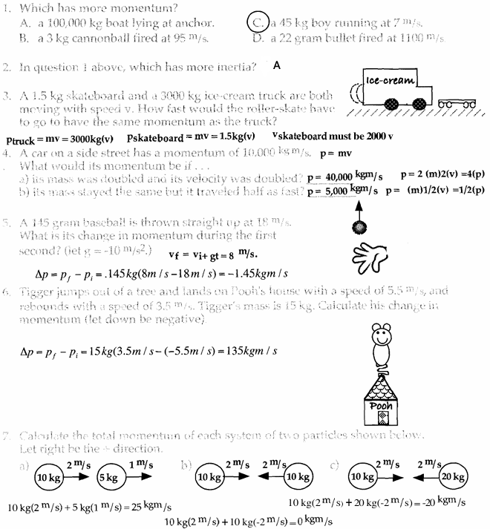

Impulse
J = F*∆t (Impulse = Force* time)

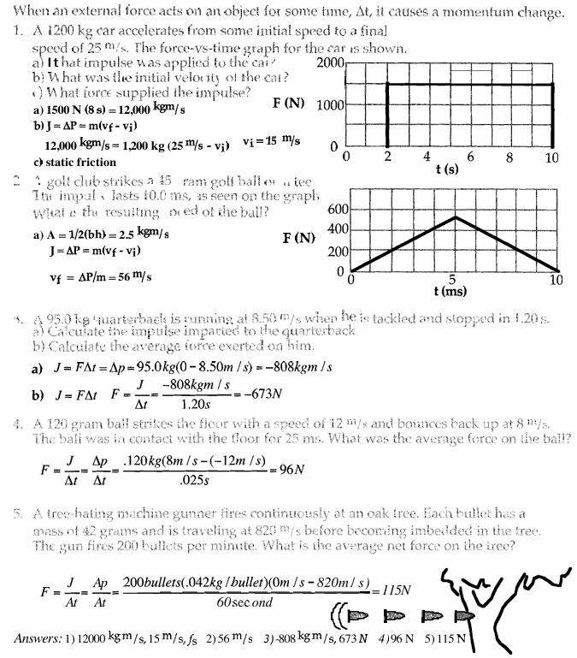

Collision 1D (Conservation of Momentum)
$P_{i}=P_{f}$ or $m_{1}v_{01}+m_{2}v_{02}=m_{1}v_{f1}+m_{2}v_{f2}$

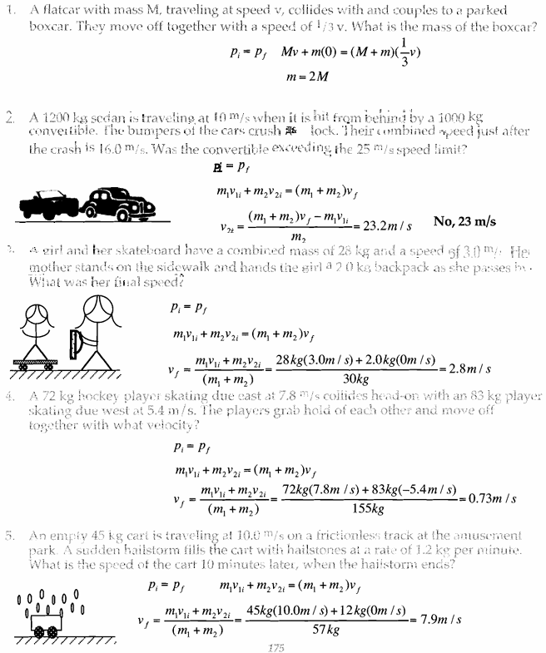

Collision 1D (Continued)
Conservation of Momentum:$P_{i}=P_{f}$ or $m_{1}v_{01}+m_{2}v_{02}=m_{1}v_{f1}+m_{2}v_{f2}$

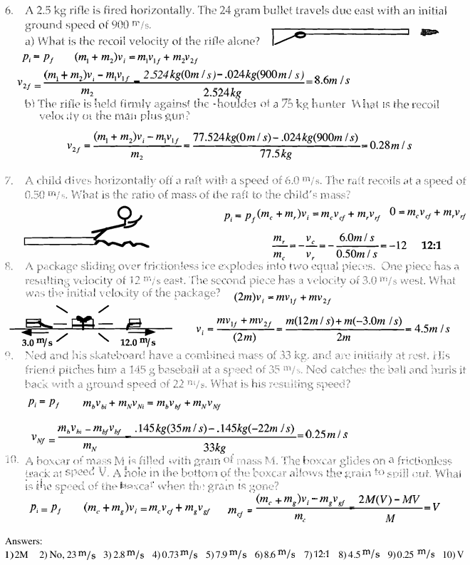

Conservation of Momentum 2D
${Momentum is conserved in x or y direction if net force in that direction is 0}_{}$
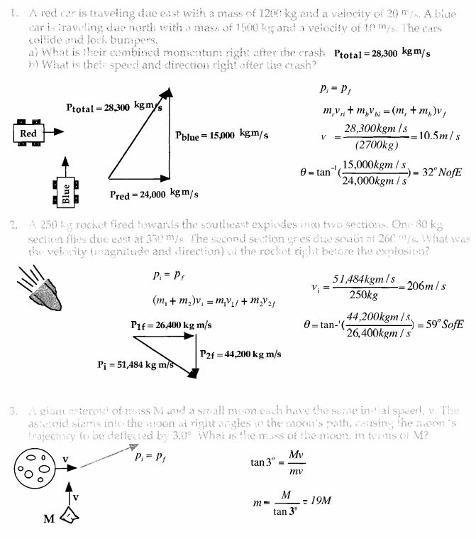

Conservation of Momentum 2D(Continued)

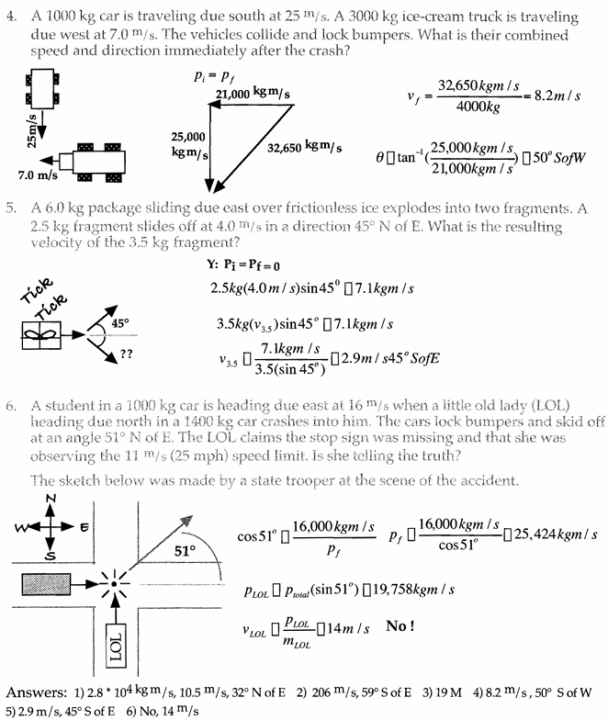

Conservation of Momentum and Energy
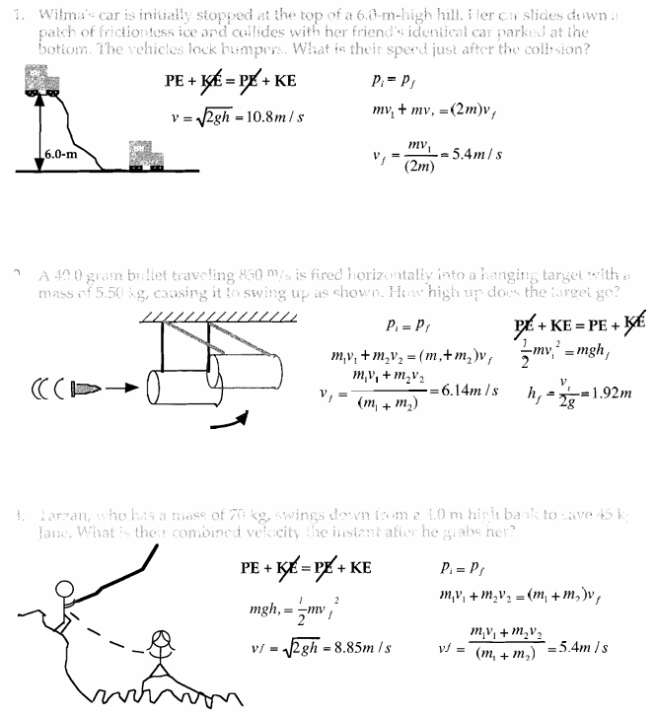

Conservation of Momentum and Energy(Continued)

